Date : 27th Jun 2022

Author : Kasshyap Paritala

Advance Excel Assignment 3

1. How and when to use the AutoSum command in excel?

How? -

A shortcut to use AutoSum is press both keys simultaneously

* + - * Key 1 🡪‘Alt’
      * Key 2 🡪 ‘=’

When? -

Condition is that it should be immediately after the last numeric row of the column and column should not be having any non-numeric values in between.

Or we can follow the below steps

**Step 1**

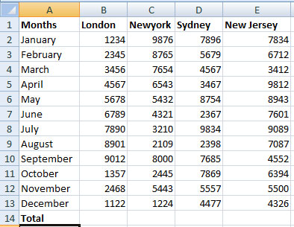

**Step 2**

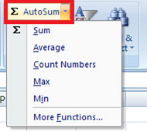

**Step 3**

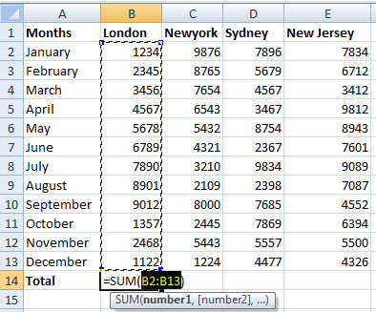

**Step 4**

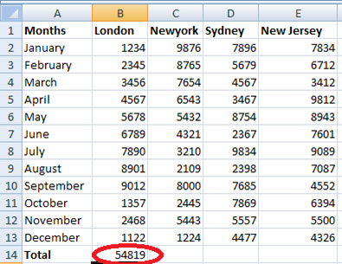

**Step 5**

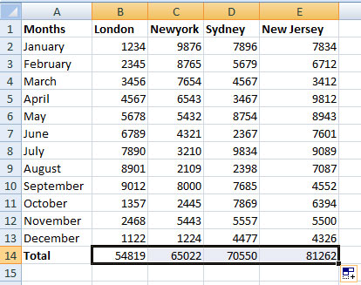

1. What is the shortcut key to perform AutoSum?

A shortcut to use AutoSum is press both keys simultaneously

* + - * Key 1 🡪‘Alt’
      * Key 2 🡪 ‘=’

1. How do you get rid of Formula that omits adjacent cells?
   * To turn off the notification "Formula Omits Adjacent Cells" you're getting, kindly follow the steps below:
     + Open Excel and then click on File.
     + Go to Options and then select Formulas.
     + Look for Error checking rules and uncheck Formulas which omit cells in a region.
     + Click OK.

Or Right Click and Ignore – like this –

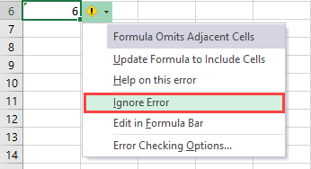

1. How do you select non-adjacent cells in Excel 2016?
   * Click on the cell.
   * Press the Control key on the keyboard. Keep holding it down while you are selecting cells.
   * Hold the left-click button on the mouse and drag it to the cells you want to select
2. What happens if you choose a column, hold down the Alt key and press the letters ocw in quick succession?
   * The column width dialogue box opens allowing you to set the exact width of the column

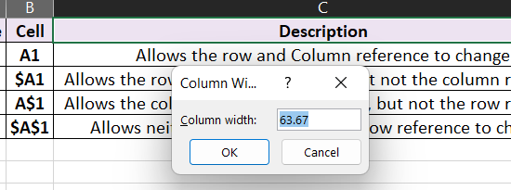

1. If you right-click on a row reference number and click on Insert, where will the row be added?
   * It would show us the options where should the row is to be added.

